The following sections detail the standard handshaking that takes place when a 32-bit processor communicates to a slave peripheral or memory device connected to the relevant Wishbone interface port. Both of the processor's Wishbone ports can be configured for 8-, 16- or 32-bit data transfer, depending on the width of the data bus supported by the connected slave device. Configuration is achieved using the relevant IO_SEL_O or ME_SEL_O output, which defines where on the corresponding DAT_O and DAT_I lines the data appears when writing and reading respectively.

## Writing to a Slave Wishbone Peripheral Device

Data is written from the host processor (Wishbone Master) to a Wishbone-compliant peripheral device (Wishbone Slave) in accordance with the standard Wishbone data transfer handshaking protocol. This data transfer cycle can be summarized as follows:

* The host presents an address on its IO_ADR_O output for the register it wants to write to and valid data on its IO_DAT_O output. It then asserts its IO_WE_O output to specify a Write cycle
* The host defines where the data will be sent on the IO_DAT_O line using its IO_SEL_O signal
* The slave device receives the address at its ADR_I input and prepares to receive the data
* The host asserts its IO_STB_O and IO_CYC_O outputs, indicating that the transfer is to begin. The slave device, monitoring its STB_I and CYC_I inputs, reacts to this assertion by latching the data appearing at its DAT_I input into the requested register and asserting its ACK_O signal – to indicate to the host that the data has been received
* The host, monitoring its IO_ACK_I input, responds by negating the IO_STB_O and IO_CYC_O signals. At the same time, the slave device negates the ACK_O signal and the data transfer cycle is naturally terminated.

## Reading from a Slave Wishbone Peripheral Device

Data is read by the host processor (Wishbone Master) from a Wishbone-compliant peripheral device (Wishbone Slave) in accordance with the standard Wishbone data transfer handshaking protocol. This data transfer cycle can be summarized as follows:

* The host presents an address on its IO_ADR_O output for the register it wishes to read. It then negates its IO_WE_O output to specify a Read cycle
* The host defines where it expects the data to appear on its IO_DAT_I line using its IO_SEL_O signal
* The slave device receives the address at its ADR_I input and prepares to transmit the data from the selected register
* The host asserts its IO_STB_O and IO_CYC_O outputs, indicating that the transfer is to begin. The slave device, monitoring its STB_I and CYC_I inputs, reacts to this assertion by presenting the valid data from the requested register at its DAT_O output and asserting its ACK_O signal – to indicate to the host that valid data is present
* The host, monitoring its IO_ACK_I input, responds by latching the data appearing at its IO_DAT_I input and negating the IO_STB_O and IO_CYC_O signals. At the same time, the slave device negates the ACK_O signal and the data transfer cycle is naturally terminated.

## Writing to a Slave Wishbone Memory Device

Data is written from the host processor (Wishbone Master) to a Wishbone-compliant memory device or memory controller (Wishbone Slave) in accordance with the standard Wishbone data transfer handshaking protocol. This data transfer cycle can be summarized as follows:

* The host presents an address on its ME_ADR_O output for the address in memory that it wants to write to and valid data on its ME_DAT_O output. It then asserts its ME_WE_O output to specify a Write cycle
* The host defines where the data will be sent on the ME_DAT_O line using its ME_SEL_O signal
* The slave device receives the address at its ADR_I input and prepares to receive the data
* The host asserts its ME_STB_O and ME_CYC_O outputs, indicating that the transfer is to begin. The slave device, monitoring its STB_I and CYC_I inputs, reacts to this assertion by storing the data appearing at its DAT_I input at the requested address and asserting its ACK_O signal – to indicate to the host that the data has been received
* The host, monitoring its ME_ACK_I input, responds by negating the ME_STB_O and ME_CYC_O signals. At the same time, the slave device negates the ACK_O signal and the data transfer cycle is naturally terminated.

## Reading from a Slave Wishbone Memory Device

Data is read by the host processor (Wishbone Master) from a Wishbone-compliant memory device or memory controller (Wishbone Slave) in accordance with the standard Wishbone data transfer handshaking protocol. This data transfer cycle can be summarized as follows:

* The host presents an address on its ME_ADR_O output for the address in memory that it wishes to read. It then negates its ME_WE_O output to specify a Read cycle
* The host defines where it expects the data to appear on its ME_DAT_I line using its ME_SEL_O signal
* The slave device receives the address at its ADR_I input and prepares to transmit the data from the selected memory location
* The host asserts its ME_STB_O and ME_CYC_O outputs, indicating that the transfer is to begin. The slave device, monitoring its STB_I and CYC_I inputs, reacts to this assertion by presenting the valid data from the requested memory location at its DAT_O output and asserting its ACK_O signal – to indicate to the host that valid data is present
* The host, monitoring its ME_ACK_I input, responds by latching the data appearing at its ME_DAT_I input and negating the ME_STB_O and ME_CYC_O signals. At the same time, the slave device negates the ACK_O signal and the data transfer cycle is naturally terminated.

## Wishbone Timing

Figure 1 shows the signal timing for a standard single Wishbone Write Cycle (left) and Read Cycle (right), respectively. The timing diagrams are presented assuming point-to-point connection of the Master and Slave interfaces, with only signals on the Master side of the interface shown. Note that cycle speed can be throttled by the Slave device inserting wait states (represented as WSS on the diagrams) before asserting its acknowledgement line (ACK_I input at the Master side).

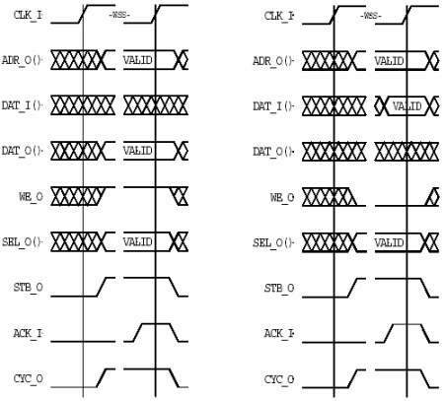   
Figure 1. Timing diagrams for single Wishbone Write (left) and Read (right) cycles.

* [Printer-friendly version](http://techdocs.altium.com/print/212714)
* [PDF version](http://techdocs.altium.com/printpdf/212714)